

《软件工程原理与应用》

系统设计报告

食堂餐点预定系统

|  |  |
| --- | --- |
| 小 组 | 104 B 朱浩瑜 兰振东 王子润 植阳 |
| 学院 | 计算机科学与技术学院/人工智能学院/软件学院 |
| 专业 | 计算机科学与技术 |
| 班级 | 1622104 1622103 |

二〇二四年十一月

目录

一、引言 2

1、编写目的 2

2、背景 3

3、定义 3

4、参考文献 4

二、界面设计 4

1、User类 4

2、 Administrator类 11

3、 Store类 14

4、 Item类 18

5、 Order类 25

6、Comment类 28

三、事务逻辑设计 31

1、User类 31

2、Administrator类 34

3、Store类 36

4、Item类 38

5、Order类 40

7、Comment类 41

四、数据库设计 43

1、 User类 43

2、 Store类 43

3、 Item类 43

4、 Order类 44

5、 OrderItem类 44

6、 Comment类 44

# 一、引言

## 1、编写目的

需求说明书目的是使用户和软件开发者双方对该软件有一个共同的理解，使之成为整个开发工作的基础。便于用户、开发人员进行理解和交流，反映出用户问题的结构，可以作为软件开发工作的基础和依据，并作为确认测试和验收的依据。

预期读者：软件设计者和测试者。

## 2、背景

说明：

1. 待开发的软件系统的名称：食堂餐点预定平台
2. 本项目的任务提出者：朱浩瑜 兰振东 植阳 王子润；
3. 本项目的任务开发者：朱浩瑜 兰振东 植阳 王子润；
4. 用户：高校食堂商户 教职工 学生。
5. 实现该软件的计算中心或计算机网络：南京航空航天大学计算中心。

## 3、定义

|  |  |
| --- | --- |
| 名称 | 说明 |
| 账号 | 用户注册时登记的用户名（手机或邮箱）及密码 |
| 用户分类 | 普通用户、商家用户、管理员用户 |
| 账户信息管理 | 用户与管理员都可通过该模块对自己的信息进行增加、查询、修改、删除操作，分别对应注册、登录、修改用户信息及找回密码、注销，管理员拥有对所有用户的信息进行各项操作的权限 |
| 创建菜单 | 商家用户填写需要创建的菜单后送审 |
| 修改菜单 | 发布该信息的商家用户修改菜单后送审 |
| 查看菜单 | 所有用户均可查看已发布的菜单 |
| 审核菜单 | 管理员审核商家用户发布的菜单信息，可以选择通过或退回 |
| 创建订单信息 | 普通用户选择餐点生成订单，结算时将订单发送至商家用户 |
| 审核订单信息 | 商家对用户订单进行反馈，选择接单或退回 |
| 删除订单信息 | 用户可删除已提交未被商家确认的订单，管理员可删除全部预约订单 |
| 查看订单信息 | 普通用户和商家用户可以查看与自己相关的的订单信息，管理员可查看全部订单 |
| 发表评论 | 用户可以对商家进行评论 |
| 查看评论 | 用户查看其他人或自己发布过的评论 |
| 审核评论 | 管理员审核用户发表的评论，可以选择通过或退回 |
| 删除评论 | 发布该评论的用户或管理员可以删除评论 |

## 4、参考文献

|  |  |  |
| --- | --- | --- |
| 编号 | 参考资料 | 作者 |
| 1 | 《软件工程（第四版）》，高等教育出版社，2019 | 齐治昌等 |
| 2 | 《构建之法（第二版）》，人民邮电出版社，2015 | 邹欣 |

# 二、界面设计

## 1、User类

|  |  |
| --- | --- |
| signup.html | 普通用户注册页面 |

web：

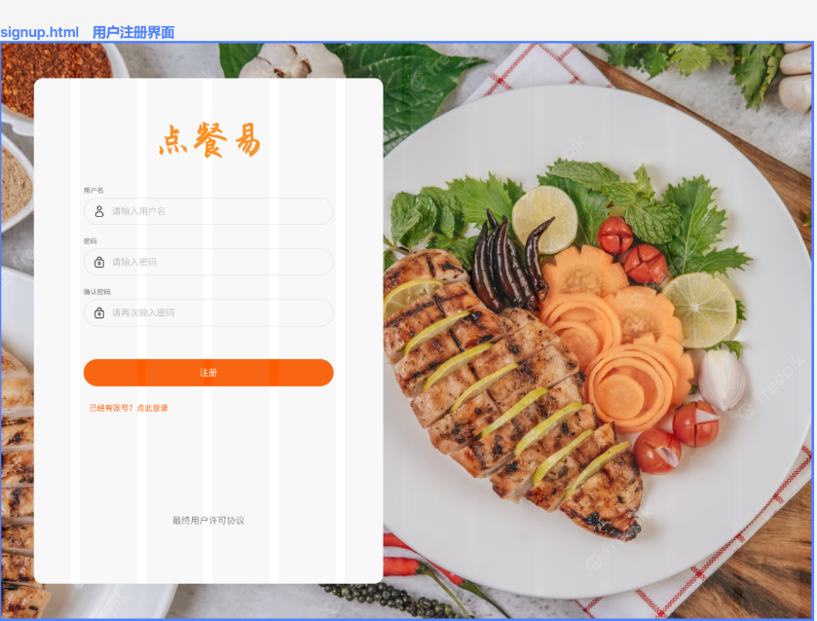

app:

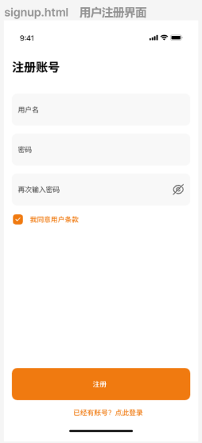

|  |  |
| --- | --- |
| login.html | 登录页面 |

web:

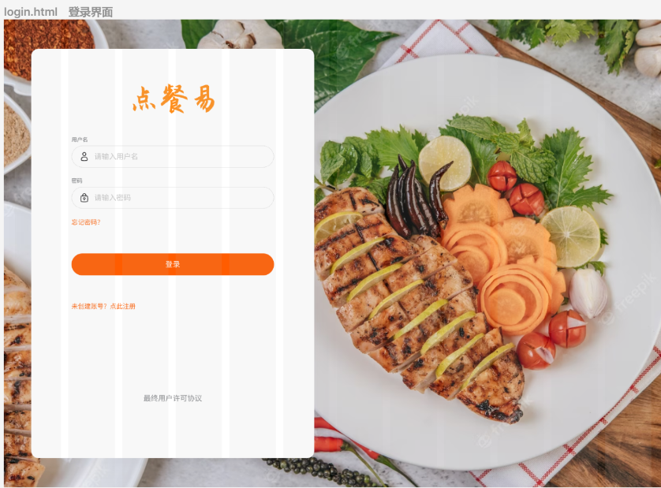

app:

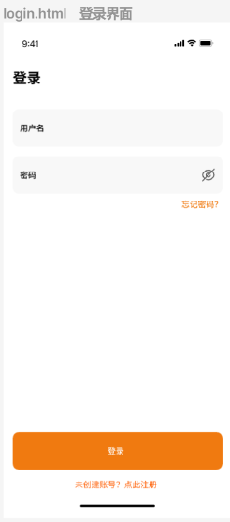

|  |  |
| --- | --- |
| homePage.html | 首页 |

web:



app:

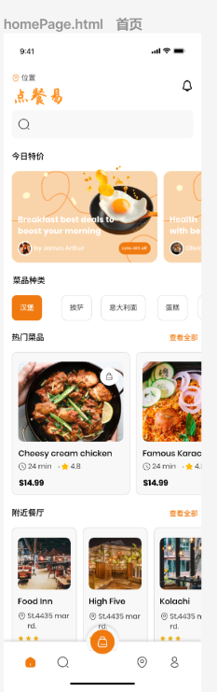

|  |  |
| --- | --- |
| myInfo.html | 查看个人信息页面 |

web:

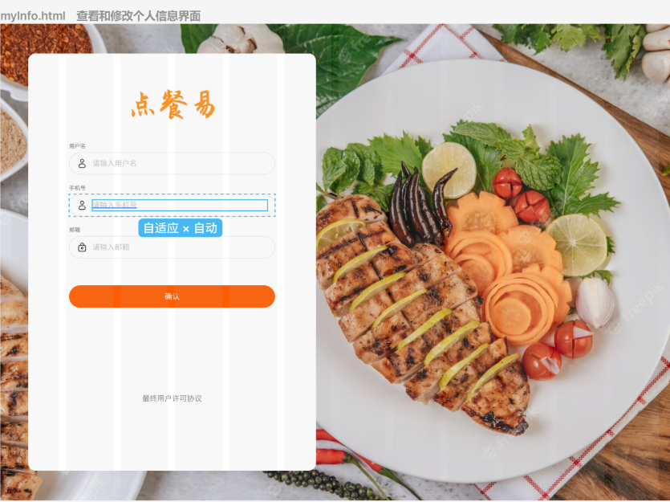

app:

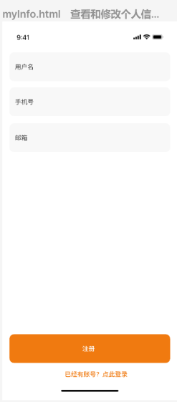

|  |  |
| --- | --- |
| updatePassword.html | 修改密码 |

web:

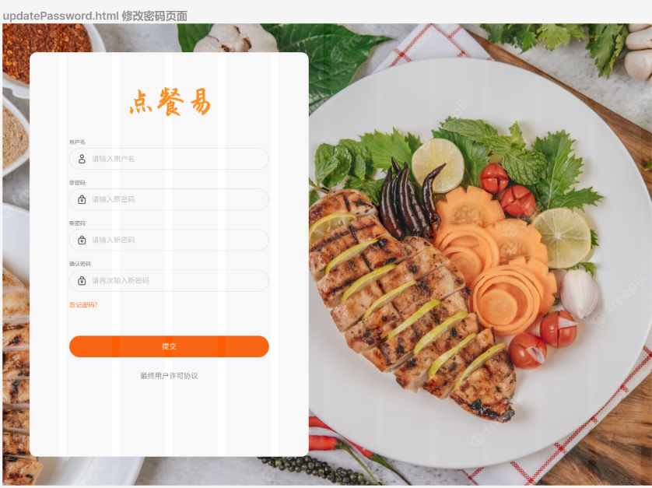

app:

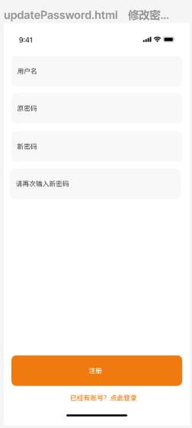

|  |  |
| --- | --- |
| resetPassword.html | 密码找回页面 |

web:

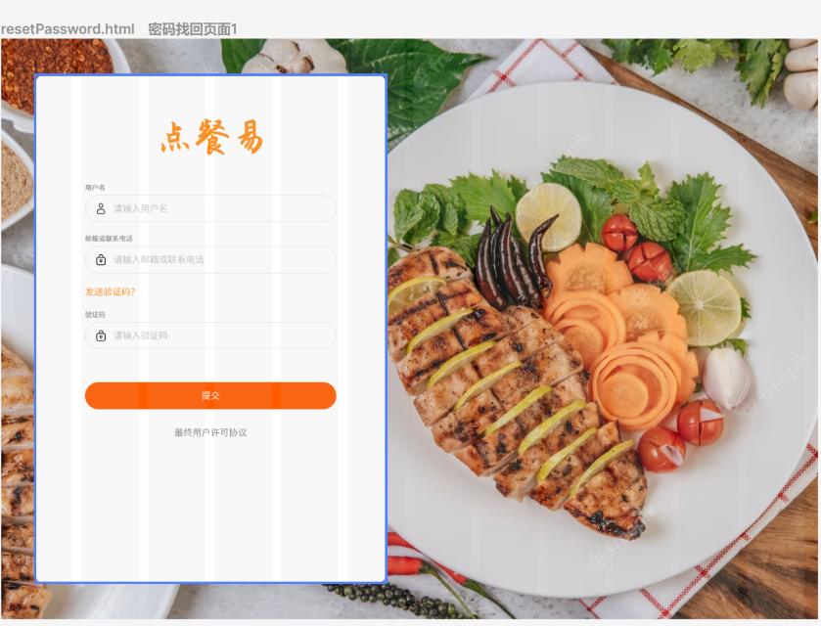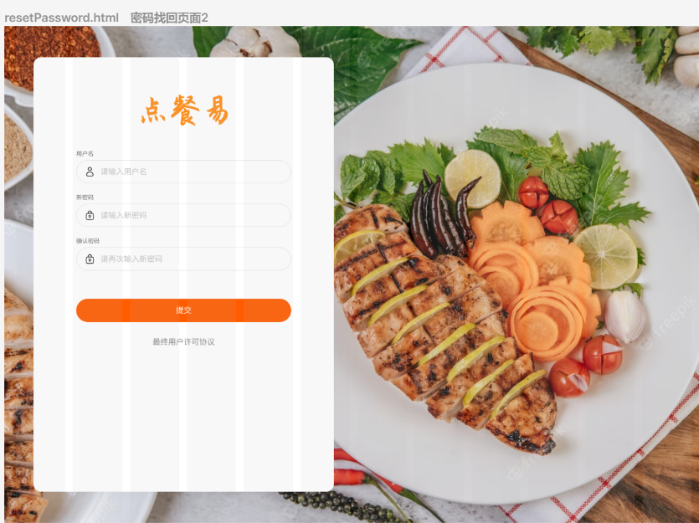

app:

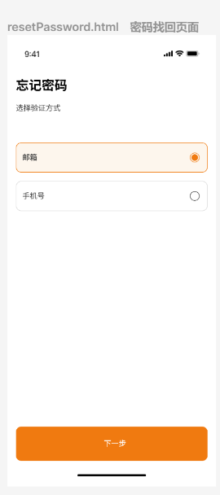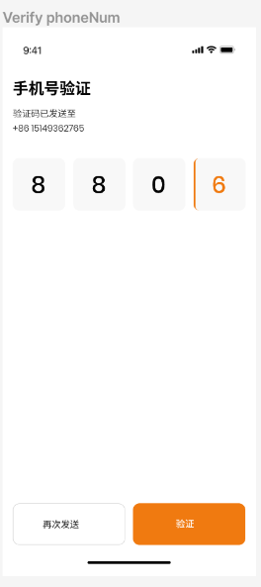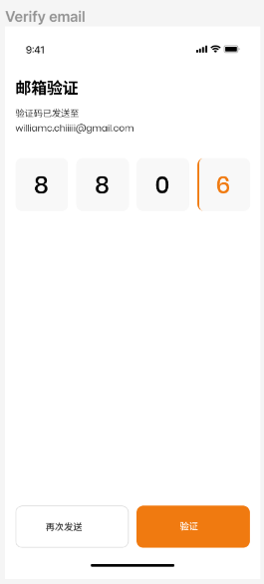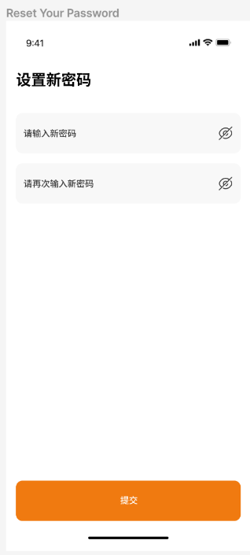

## Administrator类

|  |  |
| --- | --- |
| manageUser.html | 管理用户账号页面 |

web:

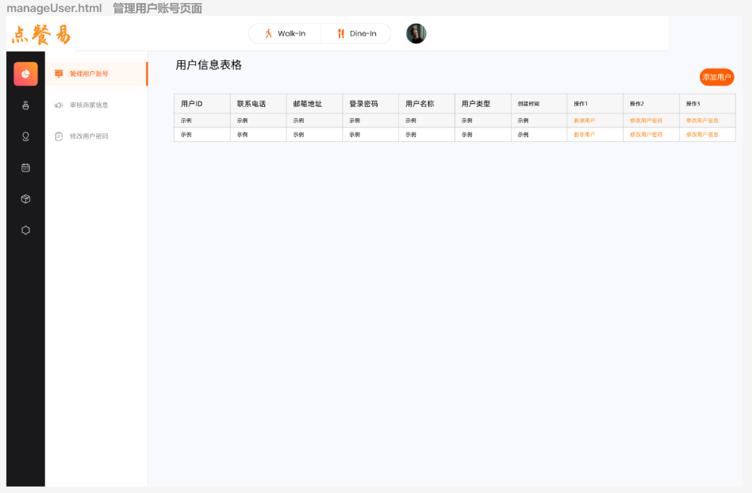

|  |  |
| --- | --- |
| userInfo.html | 查询用户结果页面 |

web:

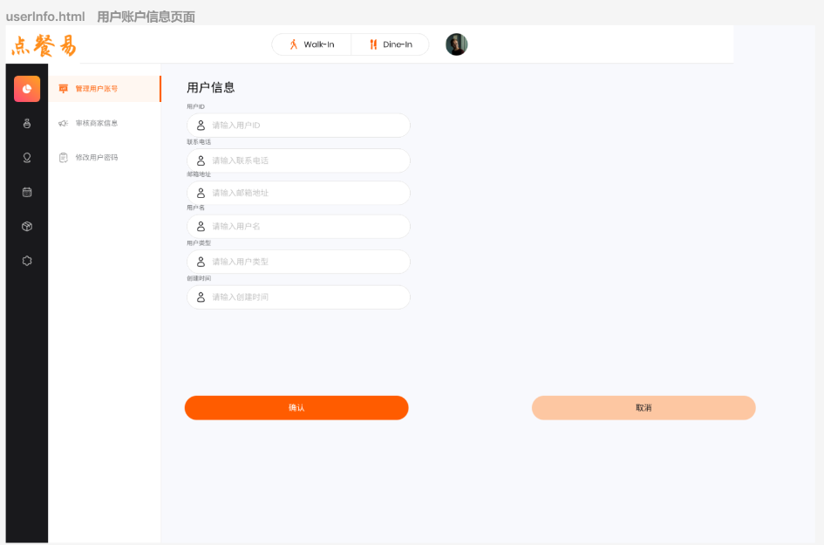

|  |  |
| --- | --- |
| reviewStoreInfo.html | 审核商家信息页面 |

web:

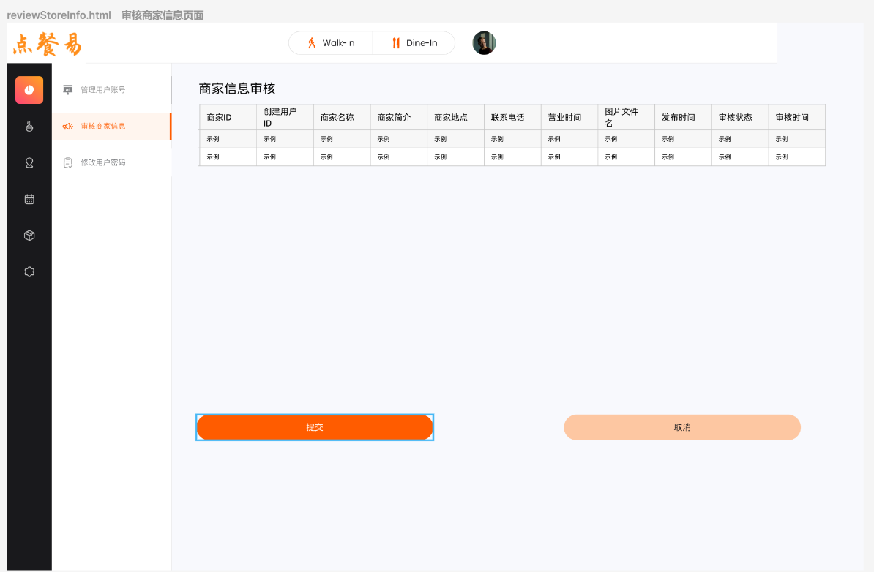

|  |  |
| --- | --- |
| changePassword.html | 修改密码页面 |

web:

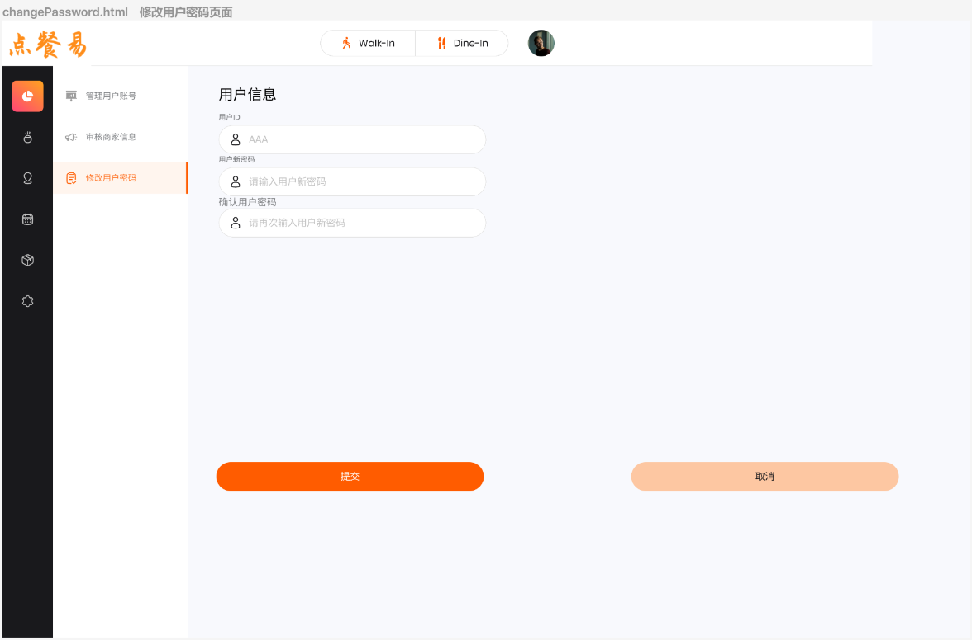

## Store类

|  |  |
| --- | --- |
| submitStoreInfo.html | 提交商家信息页面 |

web:

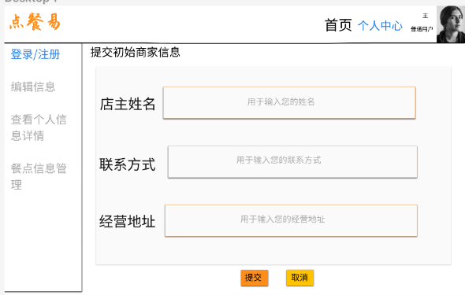

app:

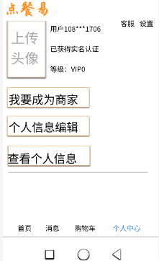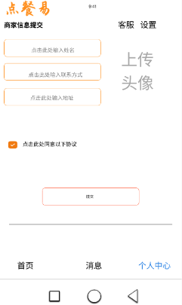

|  |  |
| --- | --- |
| updateStoreInfo.html | 编辑商家信息页面 |

web:

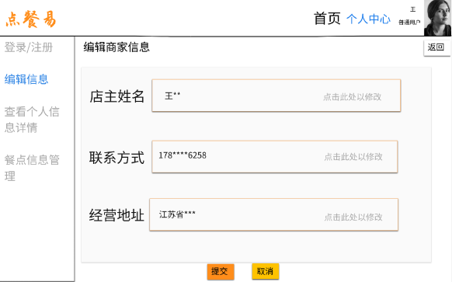

app:

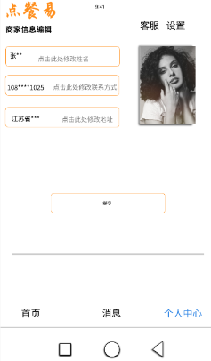

|  |  |
| --- | --- |
| displayStoreInfo.html | 商家信息详情页面 |

web:

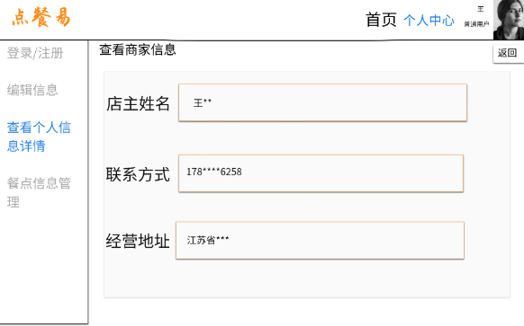

app:

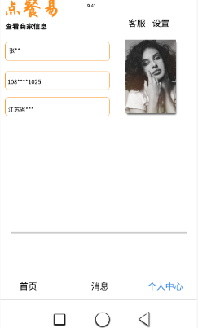

|  |  |
| --- | --- |
| manageStore.html | 管理商家信息页面 |

web:

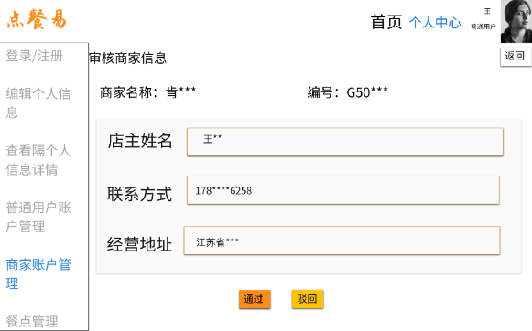

app:

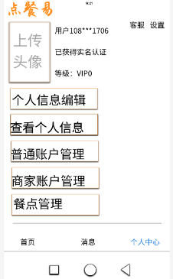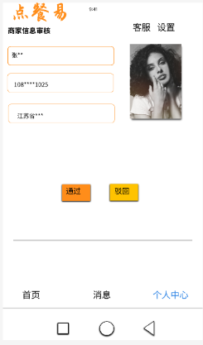

|  |  |
| --- | --- |
| storeList.html | 商家列表页面 |

web:

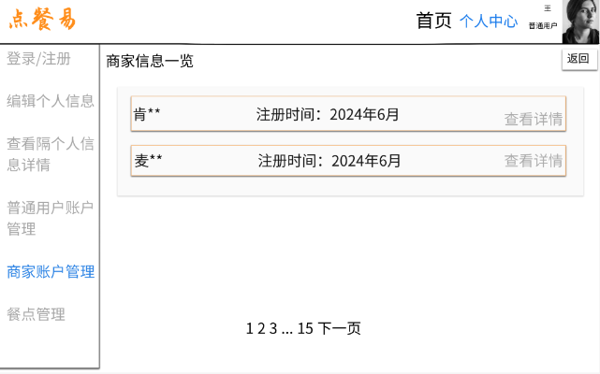

app:

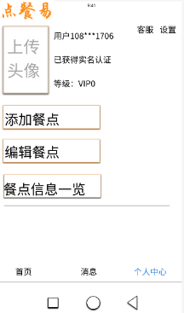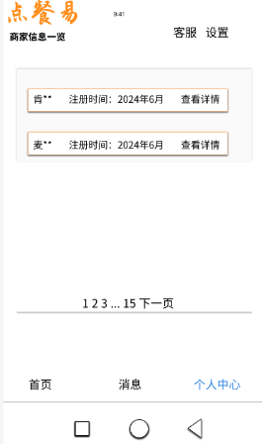

## Item类

|  |  |
| --- | --- |
| addItem.html | 添加餐点信息页面 |

web:

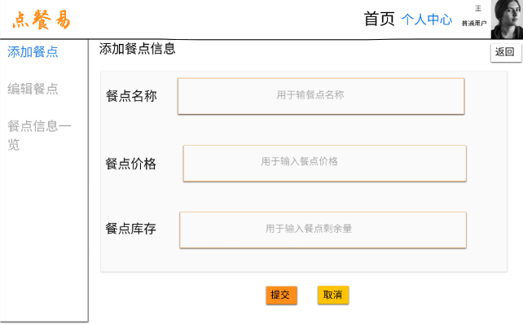

app:

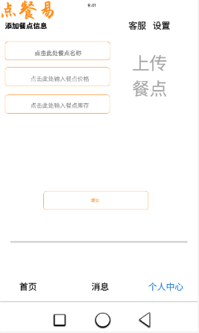

|  |  |
| --- | --- |
| EditItemInf.html | 编辑餐点信息页面 |

web:

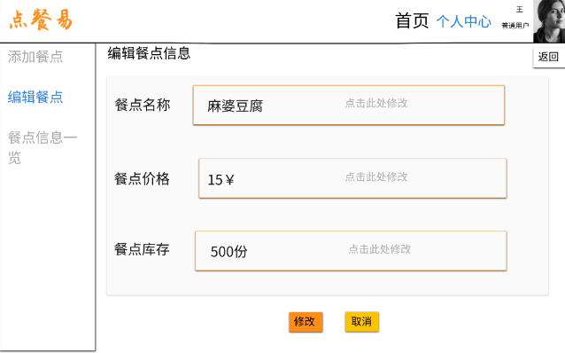

app:

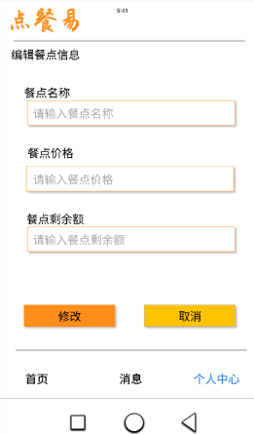

|  |  |
| --- | --- |
| showItemInf.html | 餐点列表界面 |

web:

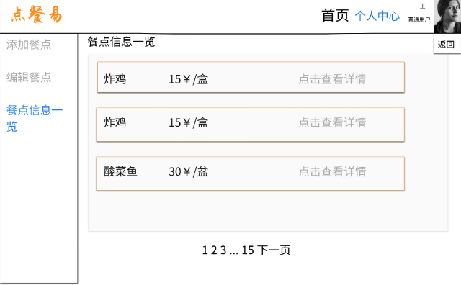

app:

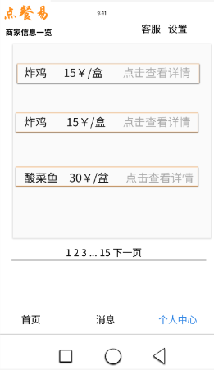

|  |  |
| --- | --- |
| ManageItemInf.html | 管理餐点页面 |

web:

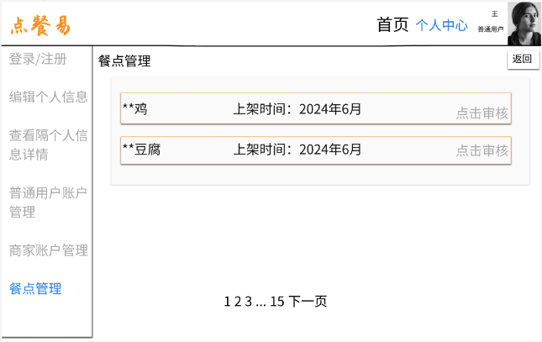

app:

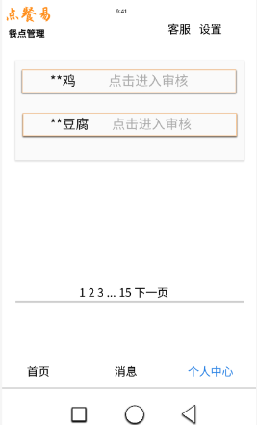

|  |  |
| --- | --- |
| AuditItemInfo.html | 审核餐点信息页面 |

web:

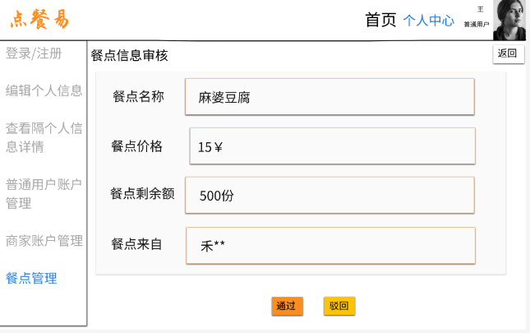

app:

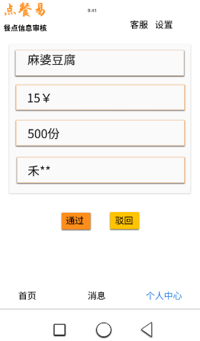

|  |  |
| --- | --- |
| selectItem.html | 用户选餐页面 |

web:

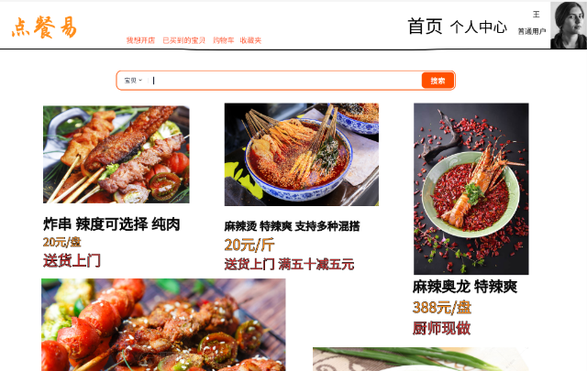

app:

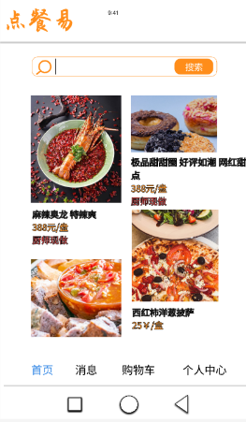

|  |  |
| --- | --- |
| ItemInfo.html | 餐点详情页面 |

web:

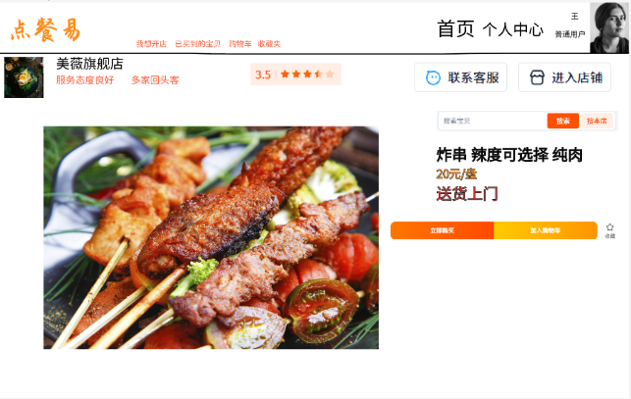

app:

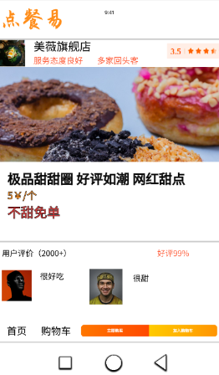

## Order类

web:

|  |  |
| --- | --- |
| submitOrder.html | 提交订单页面 |

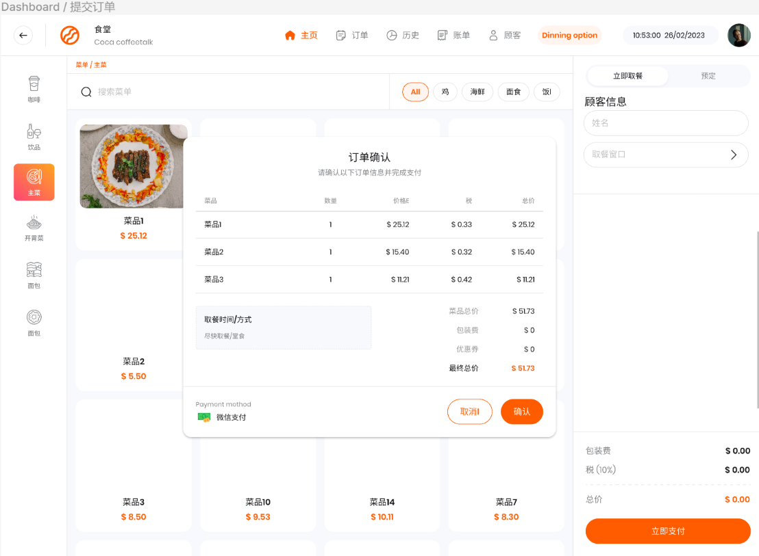

|  |  |
| --- | --- |
| storeOrder.html | 商家审核订单页面 |

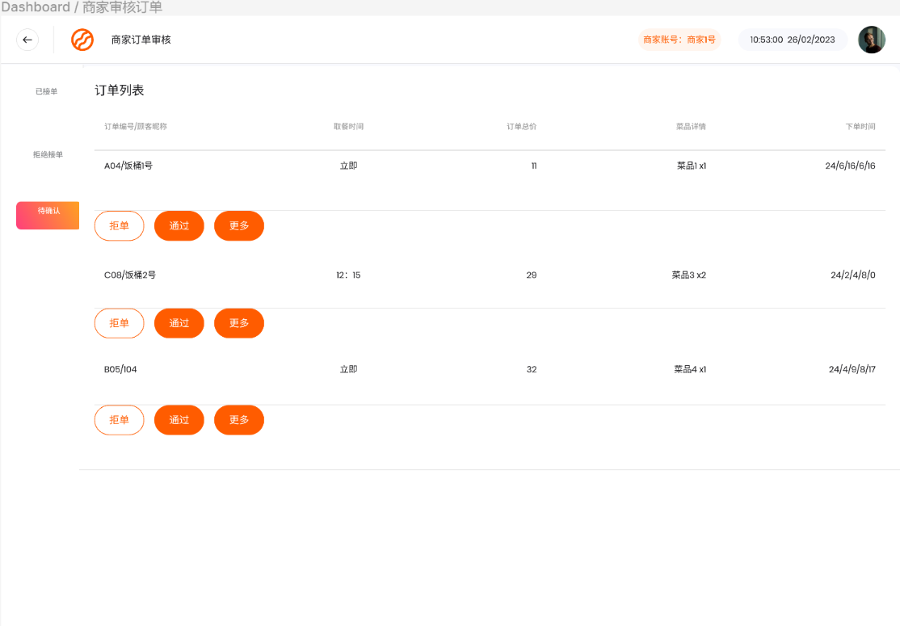

|  |  |
| --- | --- |
| myOrder.html | 用户订单页面 |

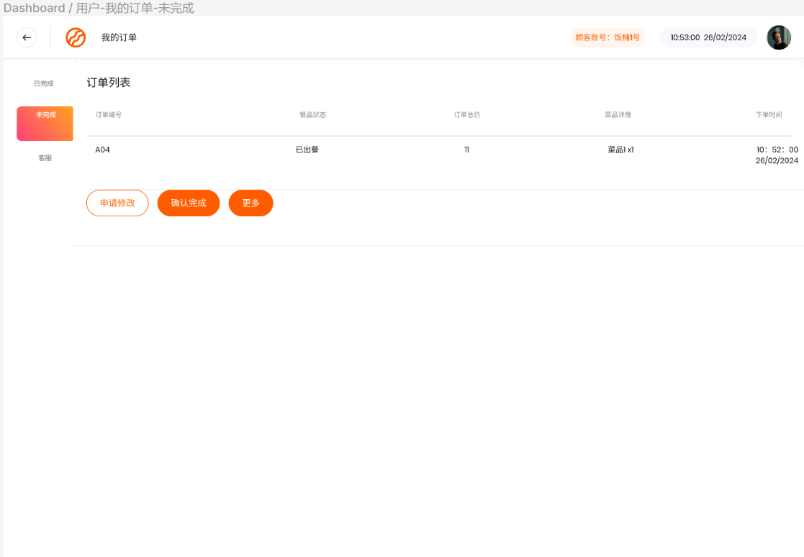

|  |  |
| --- | --- |
| manageOrder.html | 管理订单页面 |

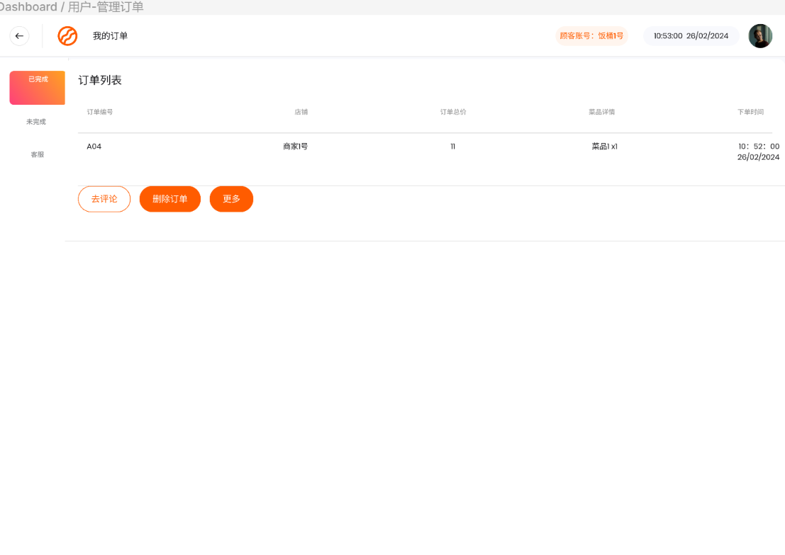

## 6、Comment类

web:

|  |  |
| --- | --- |
| publishComment.html | 发布评论页面 |

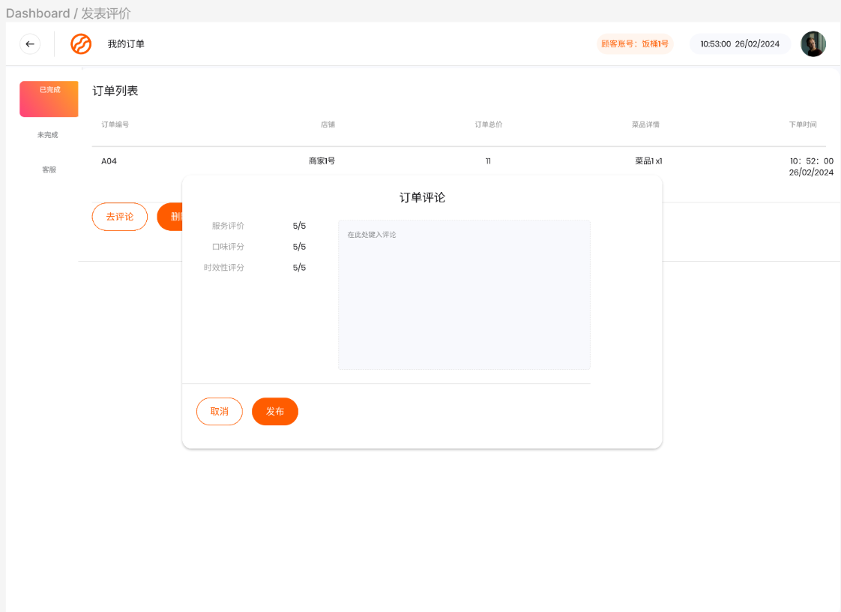

|  |  |
| --- | --- |
| storeComment.html | 商家评论页面 |

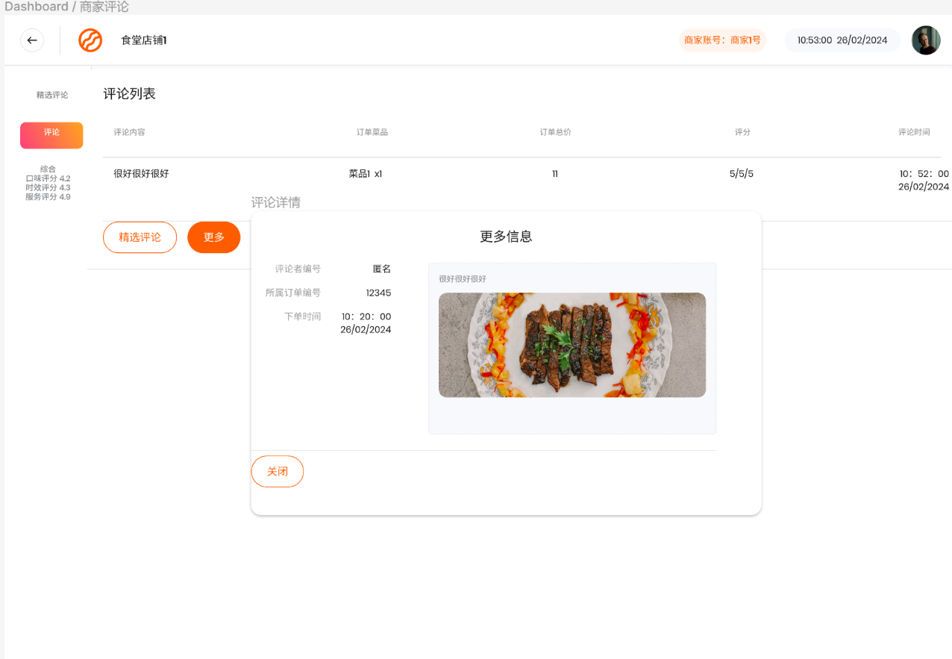

|  |  |
| --- | --- |
| myComment.html | 用户评论页面 |

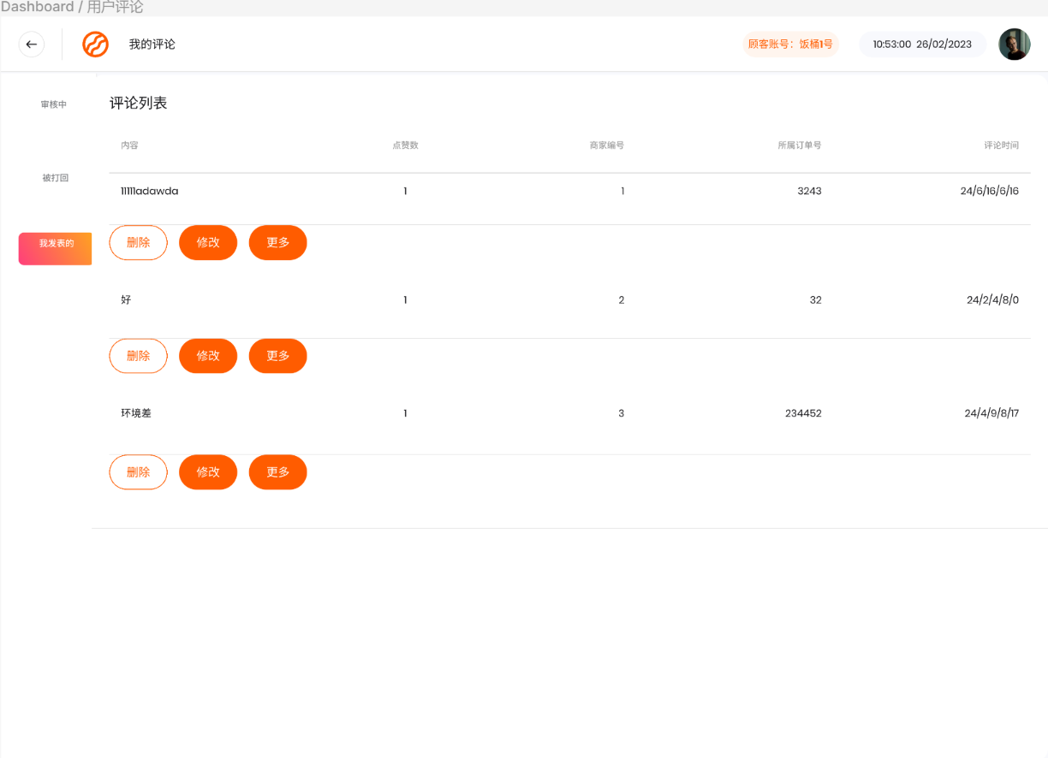

|  |  |
| --- | --- |
| commentDetail.html | 评论详情页面 |

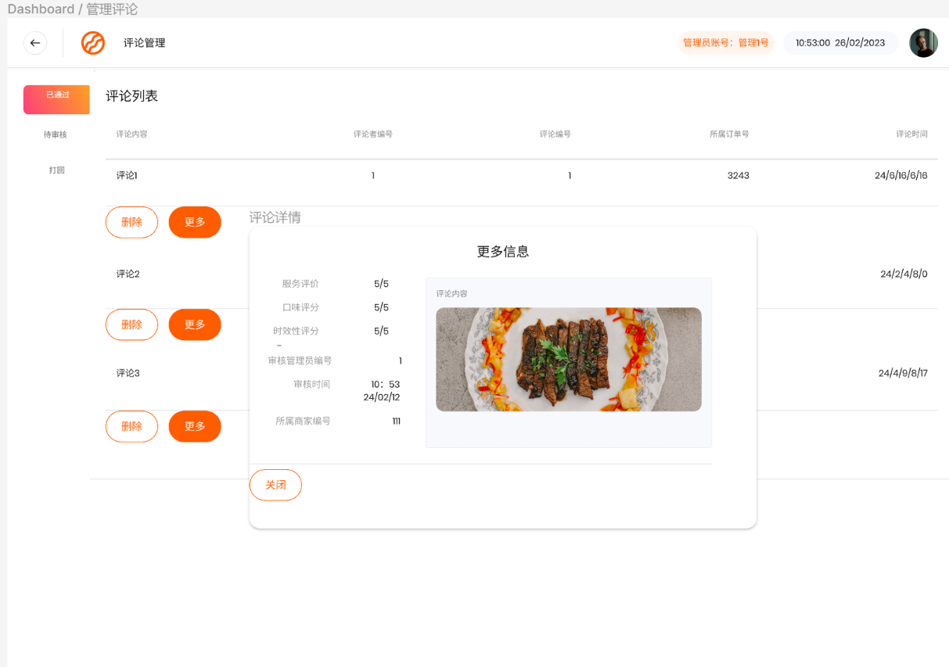

|  |  |
| --- | --- |
| manageComment.html | 管理评论页面 |

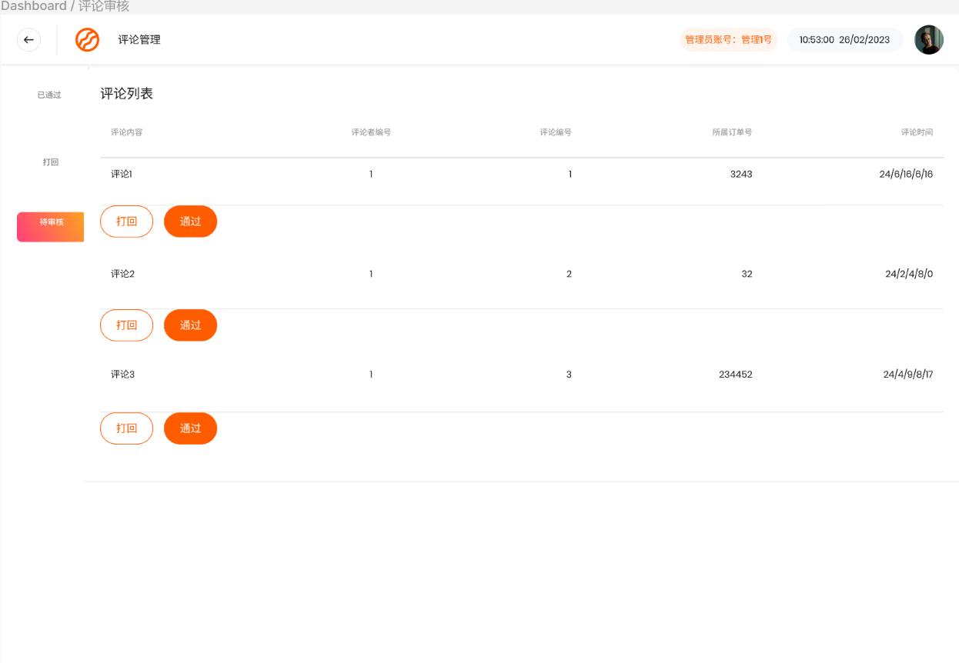

# 三、事务逻辑设计

## 1、User类

登录处理

Procedure login

Begin

choose the method of login

If (choose the Account password login) then

get the email or phonenumber and password from signin.html

find the usermailbox and password in the database

If (usermailbox not found ) or (usermailbox exist but inputPassWord != Password indatabase )then

display error hint

Else

goto index.html

End if

Else if (choose the verification code login) then

get the phonenumber or email and the verification from signin.html

find the phonenumber or mail in the database and check the verification

If (phonenumber not found and email not found) or (the verification is not correct) then

display error hint

Else

goto index.html

End if

End if

End login

注册处理

Procedure signup

Begin

get the new_user's info from signup.html

find the email or phonenumber in the database

If (the usermailbox or phonenumber existed in the database) then

show error hint

Else

send the verification to the user with SMS or email

get and check the verification from signup.html

If (the verification is not correct) then

show error hint and let the user try again

Else

add user's info to database

goto signin.html

End if

End if

End signup

修改个人信息处理

Procedure changeUserInfo

Begin

get the changed userinfo from myInfo.html

find the user and the user's info in database

input the new info into database

goto myInfo.html

End changeUserInfo

修改密码处理

Procedure changepassword

Begin

get the originalpassword from changepassword.html

If the (inputpassword ==correct password in database) then

get two new_password which is inputted by the user twice

If (the two new_password is the same) then

find the user's info in the database

change the old_password into the new password

goto getUserInfo.html

Else

show error hint

End if

Else

show error hint

End if

End changepassword

忘记密码重置密码处理

Procedure forgetpassword

Begin

get the user's phonenumber or email from resetpassword.html

find the user's phonenumber or email in the database

If (the user's phonenumber o email is existed) then

send the verification to the user with SMS or email

get and check the verification from resetpassword.html

If (the verification is not correct) then

show error hint and let the user try again

Else

show the set_new_password page and let the user set the new password

get two new_password which is inputted by the user twice

If (the two new_password is the same) then

find the user's info in the database

change the old_password into the new-seted password

goto signin.html

Else

show error hint and let the user try again

End if

End if

Else

show error hint

End if

End forgetpassword

注销账号处理

Procedure disableUser

Begin

get the disableUser submit from myInfo.html

show cancelUser dialog

get the result from cancelUser dialog

If (the reuslt is yes) then

find the user in database

cancel the user's account and set the account is non-existent in the database

goto signin.html

Else

return to myInfo.html

End if

End cancelUser

## 2、Administrator类

登录处理

Procedure login

Begin

choose the method of login

If (choose the Account password login) then

get the usermailbox and userPassword from signin.html

find the usermailbox in the database

If (usermailbox not found) or (usermailbox exist but inputPassWord != Password indatabase )then

display error hint

Else

goto index.html

End if

End if

End login

管理用户账号

Procedure manageUser

Begin

choose the fuction of manageUser part

If (use the fuction of search_user) then

get the userinfo which is inputted to search the user

find the user whose info is correspondant to the submitted

If (the user is existed in the database) then

show the search result

Else

show no search result hint

End if

Else if (use the function of change_user_info) then

show the designated user's detailed info

get the Specific manage operation and operate the database

goto userInfo.html

Else if (use the function of delete_user_info) then

show confirm dialog

check the result from the dialog

If (the password is correct) then

delete the designated user and this user's info in the database

goto userInfo.html

Else

show error hint

End if

End if

End manageUser

管理员审核商家处理

Procedure ReviewStore

Begin

show the store's detailed info

get the result from the page

If the result is Accept then

set the status of the store

goto storeList.html

Else

send message to vendor user

delete store info

goto storeList.html

End if

End ReviewStore

## 3、Store类

商家提交信息

PROCEDURE submitStoreInfo

BEGIN

get the info from submitStoreInfo.html

IF (content is empty)THEN

display error hint

ELSE

record the time of the submission --*record the time

show the store info is waiting review

goto displayStoreInfo.html

ENDIF

END submitStoreInfo

删除商家信息

PROCEDURE deleteStoreInfo

BEGIN

get the store name from mangeStore.html

find the store name in the database

IF (the store name not found) THEN

display error message

ELSE

IF (the store has remaining order) THEN

show error hint

ELSE

delete the store from the database

display success message

goto manageStore.html

ENDIF

ENDIF

END deleteStoreInfo

修改商家信息

PROCEDURE updateStoreInfo

BEGIN

find the store in the database

get the changed storeInfo from updateStoreInfo.html

IF (the store info is corrent) THEN

input the updated store info into the database

goto displayStoreInfo.html

ELSE

show error hint

ENDIF

END updateStoreInfo

列出商家信息

PROCEDURE listStore

BEGIN

If (use the fuction of search_store) then

get the store name which is inputted to search the user

find the store whose info is correspondant to the submitted

If (the store is existed in the database) then

show the search result

Else

show no search result hint

End if

ELSE

show all stores from the database

END listStore

## 4、Item类

添加餐点信息

Procedure addItem

begin

get the item's information from addItem.html

if the information corresponding to the store info then

add item to store

goto itemList.html

else

display error info

end if

end

编辑餐点信息

Procedure editItem

begin

display item info

change in item information according to the template

submit the registration information

update item information in the database

End

删除餐点信息

Procedure manageItem

begin

get all items from manageItem.html

get user choice from the prompt

If (confirm_delete == true) then

Delete item from the database;

Show hint

return to manageItem.html

Else

show error hint

return to manageItem.html

End if

End deleteClock

end

## 5、Order类

提交订单处理

Procedure SubmitOrder

Begin

If(Login() = true and usertype is customer) then

Enter submitOrder.html

Select order items and quantity

click submit

enter address and time then pay the order

add order and set order state to awaiting review

End if

End SubmitOrder

审核订单处理

Procedure DeleteThemePost

Begin

If(login() = true and usertype is vendor) then

If( find(order)!=false or order has approved) then

return error

Else

get actions from the dialog

If action is approve then

set the order state to approved

Else

set the order state to canceled

send message to user

End if

End if

End if

End DeleteThemePost

## 7、Comment类

发表评论

Procedure Comment

Begin

If(login()=true) then

Find the store

Enter the store

Submit the comment

input the comment to database

show info

goto storeComment.html

End if

End Comment

发表评论

Procedure submitComment

Begin

If(login()=true and usertype is customer) then

Find the store

Enter the store

Submit the comment

input the comment to database

show info

goto storeComment.html

End if

End submitComment

审核评论

Procedure deleteComment

Begin

If(login()=true and usertype is customer) then

Find the Comment

display the comment at myComment.html

get choice from commentDetail.html

If choice is true then

delete comment from the database

goto myComment.html

Else

goto myComment.html

End if

End deleteComment

查看评论

Procedure storeComment

Begin

get store name

If(store name is exist) then

Find the Comment in the database

display the comment at storeComment.html

Else

show error hint

End if

End storeComment

# 四、数据库设计

## User类

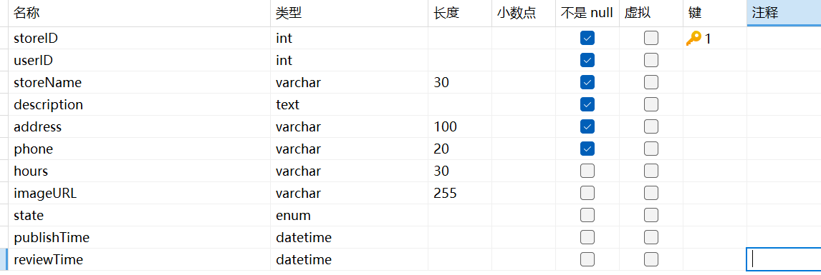

## Store类

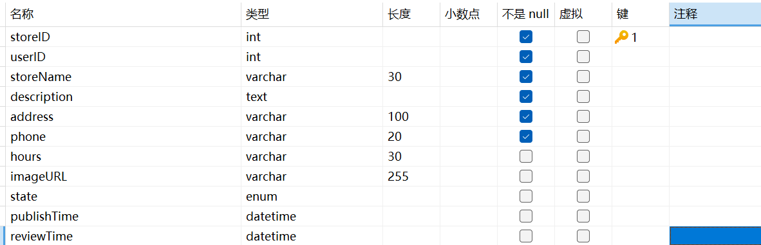

## Item类

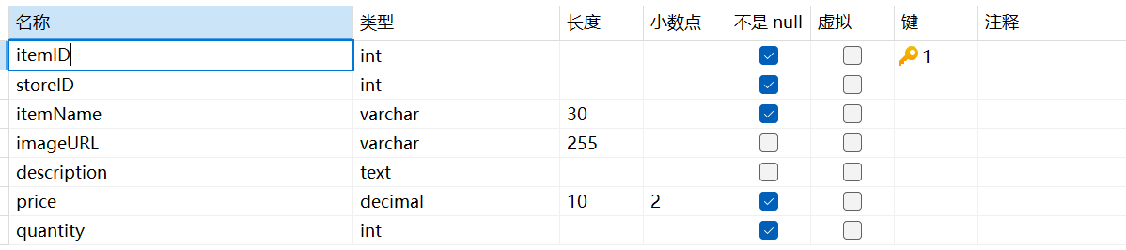

## Order类

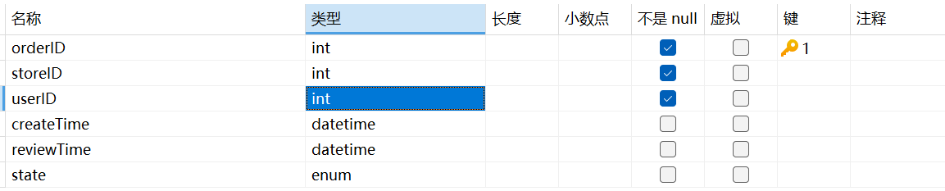

## OrderItem类

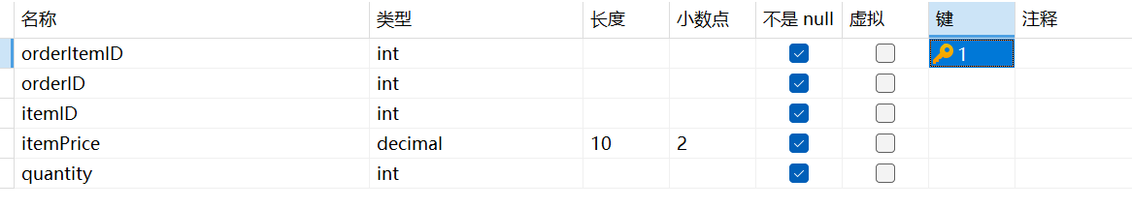

## Comment类

